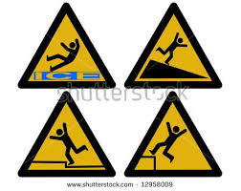
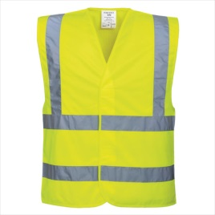
Junior Health & Safety Officer
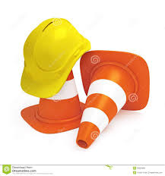
Job Description
Junior Health & Safety Officers will be responsible for:
- Reporting any health and safety issues relating to their own classroom.
- Conducting a premises inspection once per term with the Health & Safety Governor.
- Completing a Health & Safety report which will be shared with the Governors.
- Meeting once per term with the Health & Safety Governor to discuss any concerns relating to safety of the premises indoors and outdoors and of parking outside of the school
Your name:
Your class:

Please give your reasons for applying to become a Junior Health & Safety Officer. Please use this box for your reply. Thank you.

_____________________________________________________________________________________________

_____________________________________________________________________________________________

_____________________________________________________________________________________________

_____________________________________________________________________________________________

_____________________________________________________________________________________________

_____________________________________________________________________________________________

_____________________________________________________________________________________________

_____________________________________________________________________________________________

_____________________________________________________________________________________________

Shortlisting and interviews will take place during the first two weeks after half term.
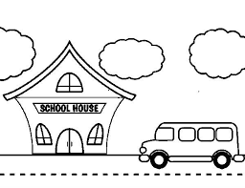
Application forms to be returned to Mrs Karen Partridge, Health & Safety Governor, C/O School Office.
